Handmade Anemometer Calibration
Project report made by: Miruna-Andreea Mondescu

1.Introduction
An anemometer is a device used to measure wind speed.
It has multiple practical applications and is widely used in meteorology (weather forecasting), aviation (flight safety assessment), wind farms and Heating, Ventilation and Air Conditioning Systems.
During the device fabrication laboratory sessions, we build a simple device, using basic components, and processed the collected data applying physical principles. We digitalized the measurements by integrating an infrared (IR) sensor connected to an Arduino microcontroller.

2.Theoretical background

2.1. Working principle of an anemometer
An anemometer consists of an rotating system that turns with constant speed when exposed to wind. Therefore a commonly used design involves cups or plates fixed on a vertical pivot support that allows rotation but constrains translation. The number of rotations within a certain time interval is directly poportional to the wind speed.

2.2. Working principle of the infrared (IR) sensor and use of Arduino
The IR sensor acts as a proximity sensor, sending a signal to the Arduino microcontroller every time a full (2π rad) roatation of the shaft is detected.
It consists of 2 main components: an IR led emitting diode, the transmitter, and a phototransistor, the reciever.
The IR LED is connected to a 5V source by a limiting resistance 200 Ω and emits a continuous infrared beam which is invisible to the human eye. When a reflecting surface such as a piece of aluminium foil passes through the front of the sensor, a part of the emitted radiation is reflected back to the reciever.
The phototransistor, also connected to a 5V source by a 4.7 Ω pull up resistance is aimed to detect electromagnetic radiation with wavelengths longer than visible light, typically ranging from 0.7 to 14 μm.
The aluminium foil must be placed on the rotating area, close engough to the photocells of the transistor that will generate an electric current due to the internal photoelectric effect.
*Photoelectric effect= infrared photons hit the semiconductor in the photransistor; they release electrons from its internal structure; the result is an electric current proportional to the intensity of the received light;
Each current peak corresponds to one rotation. The Arduino read these pulses and counts how many occur per second. It uses physical formulas to obtain the wind speed based on the rotational speed of the device. The final result is either displayed or stored by the microcontroller.
The arduino board also serves as a power source for the IR sensor components.

2.3 Equations

2.3.1. Rotation period: t (s)
$$t=\frac{T}{N}$$
Where: T= total time
N= the number of rotations during the total time

2.3.2. Handmade Anemometer speed: v(m/s)
$$v=\frac{2*π*r}{t}$$
Where: r= radius of the anemometer
π= pi constant= 3.14159..

2.3.3. Mean value: x̄
$$\bar{x}=\frac{Σ_{i=1}^{n}x_{i}}{n}$$
Where: n= number of measurements
x_{i}= measured value

2.3.4. Calibration coefficient: CF
$$CF=\frac{vDA}{vHA}$$
Where: vDA= mean wind speed registerd by the Digital Anemometer
vHA= mean wind speed registerd by the Handmade Anemometer

2.3.5. Calibrated speed value of the Handmade Anemometer: v_{HA(cal)}
$$vHA\left(cal\right)=vHA*CF$$

2.3.6. Standard deviation:σ
$$σ=Σ_{i=1}^{n}\frac{{\left(x_{i}-\overline{x}\right)}^{2}}{n-1}$$

2.3.7. Total measurement uncertainty (Rot Sum of Squares Method): σ_{comb}
$$σcomb=\sqrt{{σDA}^{2}+{σHA}^{2}}$$

Where: σDA= standard deviation of Digital Anemometer
σHA= standard deviation of Handmade Anemometer

3. Materials and methods

3.1. Materials
- 5 x cardboard cups
- 4 x plastic straws
- 1 screw (metal shaft)
- 1 pencil with an eraser tip
- 1 cardboard box
- 1cardboard disk
- aluminium foil
- a blok of basalt wool
-one hole punch
- hot glue, double-sided tape, scissors, ruler

3.2 Assembly method
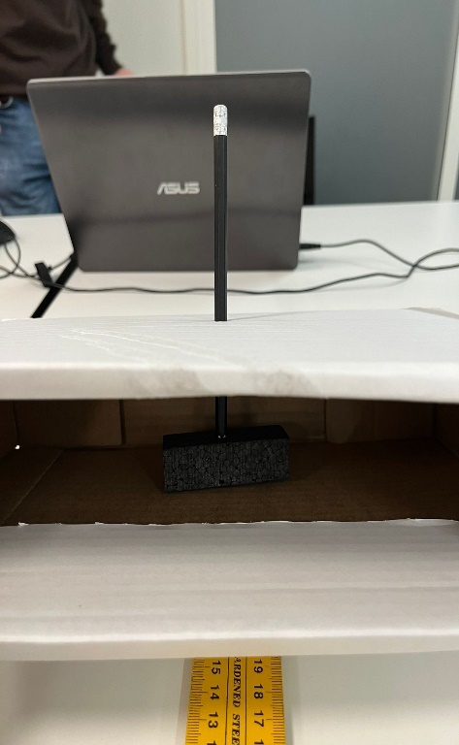
The assembly process began with manufacturing the rotor cup. 4 of the cups were perforated laterally kepping resonable distance between the 2 holes in each cup to prevent oscillations. Each straw was inserted through these openings. The opposite ends of the straws were placed inside the 5 th cup, whose bottom had been removed, trough 4 simetrical holes and glued in a cross within its diameter. In the middle we fixed a screw, as the rotational axis (Picture 1).
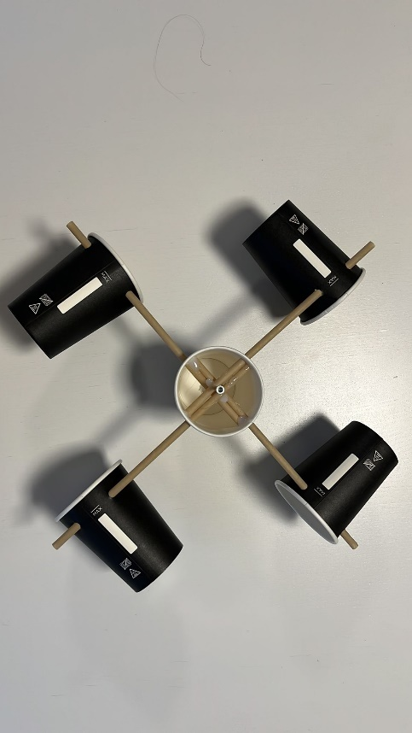

Picture 1- Rotor cup and Picture 2- Supporting pencil
rotational axis
Then, to create a sistem that can easily rotate, we sticked the tip of the screw into the eraser positioned at the end of a pencil. The pencil was placed vertically through a box to ensure stability and its lead was anchored into a blok of basalt wool situated at the bottom of the box (Picture 2).
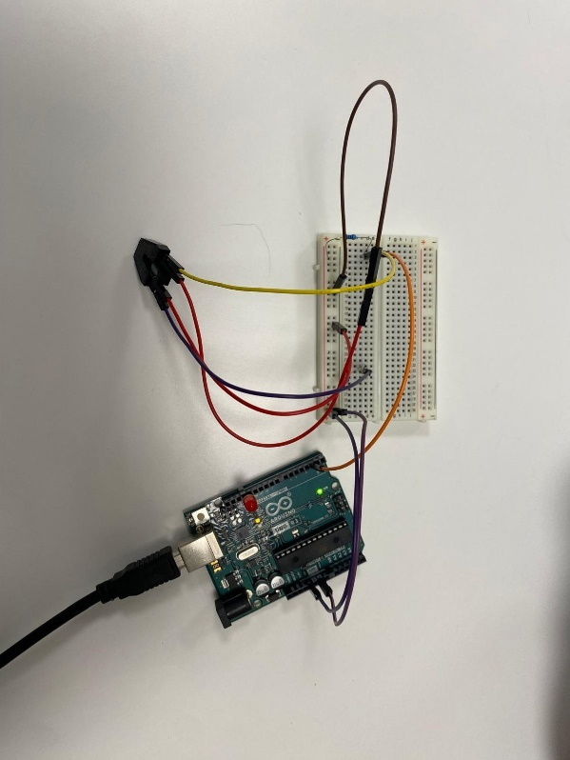
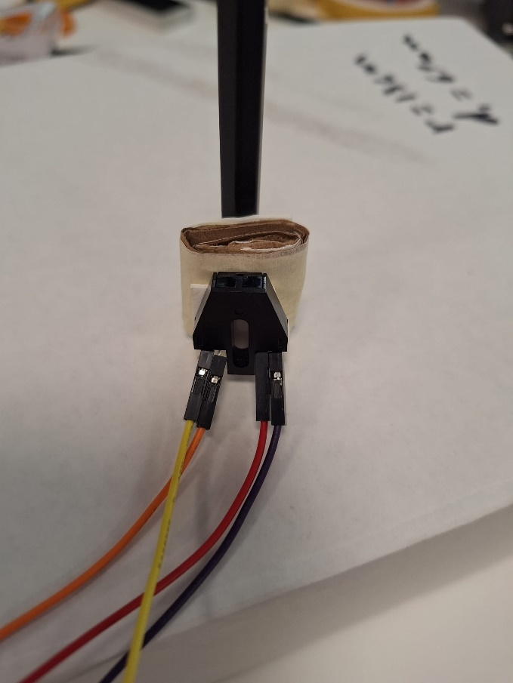

Picture 3- IR sensor placement Picture 4- Arduino Board and
Connections
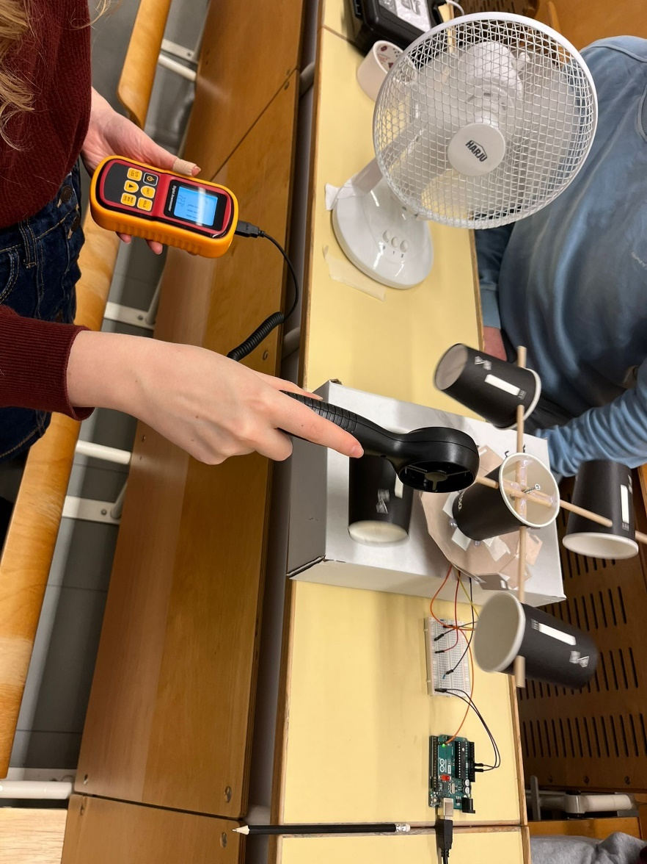
A thin reflective slice of aluminium foil was glued on the down side of the cardboard disk. The disk was then fixed at the bottom of the supporting cup with double-sided tape.
The IR sensor was placed right under the disk (less than 5mm), without touching it, with a thin elevation layer made of double-sided tape between the pencil and its actual position (Picture 3). The sensor is powerd by a voltage source from the arduino board (Picture 4).

Picture 5- Overall view of the system
Our overall design was aimed to minimize friction and undesired translational motion and to create a stable and clear envoirnment for the IR sensor.

3.3.Measurement methods
Regardless of the chosen method, the basic ideea of the anemometer is to count how many rotations occur in a given period of time, in other words, to measure the rotational period/frequency. This quantity is easily processed with equations 2.3.1 and 2.3.2 in order to obtain the system velocity. For accurate results, calibration with a standardized reference device is mandatory.

3.3.1. Measuring the rotation time with a timer
The device allows manual measurement of the rotation time. It can be done marking one of the cups (for better visual precision) and using a stopwatch to measure how long it takes for that point to pass in front of the observator a certain number of times. (ex: 10 rotations- 20 s> rotation time= 2s)

3.3.2. Measuring the rotation time using the signals produced by the IR sensor
As previously described (2.2), the infrared sensor generates an electric signal every time a full rotation is completed. Therefore, the Arduino programe, automaticaly detects the period of rotation beeing the time difference between 2 consecutive signal peaks.

4.Results
The diameter of the cup ( at the largest point) and the radius of the anemometer( distance starting from the dowel and ending at the centre of an outer cup) were measured.
Table 1- Handmade Anemometer
Diameter of the cup d (m) | Length of the straw = radius of anemometer, r (m)
0.069 | 0.13

Calibration process for the Handmade Anemometer without IR sensor (3.3.1)
In order to complete this process the calibration coefficient has to be obtained. Average speed values are required. The measurements are repeted keeping constant both the distance between the fan and the Digital/Handmade Anemometer and the fan power.

Table 2- Wind speed results of the uncalibrated
Handmade Anemometer and Digital Anemometer
Serial number | Number of Rotations N | Total time  T(s) | Time of one Rotation t= T/N (s) | The wind speed of uncalibrated Handmade Anemometer v_{HA}(m/s) =  2* π*r/t | The Wind speed of Digital Anemometer v_{DA} (m/s)
1 | 10 | 11.84 | 1.184 | 0.689 | 1.40
2 | 10 | 11.89 | 1.189 | 0.686 | 1.60
3 | 10 | 11.38 | 1.138 | 0.717 | 1.56
4 | 10 | 10.86 | 1.086 | 0.752 | 1.70
5 | 10 | 11.51 | 1.151 | 0.709 | 1.70
Average |  |  |  | 0.710 | 1.59
Standard deviation |  |  |  | 0.0266 | 0.1238

From equation 2.3.4. : $CF=\frac{1.59}{0.710}=2.239$
Further we use equation 2.3.5 in order to obtain the calibrated speed value.

Table 3 -The calibrated wind speed of the Handmade Anemometer

Serial number | Number of Rotations N | Total time  T(s) | Time of one Rotation t= T/N (s) | Calibration coefficient  (CF) | Calibrated wind speed of Handmade Anemometer  V_{HA(cal)} (m/s)
1 | 10 | 11.84 | 1.184 | 2.239 | 1.543
2 | 10 | 11.89 | 1.189 |  | 1.536
3 | 10 | 11.38 | 1.138 |  | 1.605
4 | 10 | 10.86 | 1.086 |  | 1.684
5 | 10 | 11.51 | 1.151 |  | 1.587
Average |  |  |  |  | 1.591
Standard deviation |  |  |  |  | 0.053

Calibration process for the Handmade Anemometer with IR sensor (3.3.1)
In order to complete this process the calibration coefficient has to be obtained. Average speed values are required. The measurements are repeted keeping constant both the distance between the fan and the Digital/Handmade Anemometer and the fan power.

Table 4- Wind speed results of the Digital Anemometer and uncalibrated Handmade Anemometer with IR sensor

Serial number | Wind speed of Digital Anemometer, v_{DA} (m/s) | Wind speed of Handmade Anemometer with IR sensor, v_{HA} (m/s)
1 | 1.4 | 1.14
2 | 1.6 | 1.31
3 | 1.56 | 1.31
4 | 1.7 | 1.31
5 | 1.7 | 1.14
Average | 1.59 | 1.242
Standard deviation | 0.1238 | 0.0931

From equation 2.3.4. : $CF=\frac{1.59}{1.242}=1.28$
Further we use equation 2.3.5 in order to obtain the calibrated speed value

Table 5- The calibrated wind speed of the Handmade Anemometer with IR sensor
Serial number | Wind speed of Digital Anemometer, v_{HA} (m/s) | Calibration coefficient, CF | Wind speed of Handmade Anemometer with IR sensor, v_{HA(cal)} (m/s)
1 | 1.14 | 1.28 | 1.459
2 | 1.31 |  | 1.677
3 | 1.31 |  | 1.677
4 | 1.31 |  | 1.677
5 | 1.14 |  | 1.459
Average |  | - | 1.589
Standard deviation |  | - | 0.1066

Total measurement uncertainty of both anemometers by using the Root sum of squares method: equation 2.3.7.
-Handmade Anemometer without IR sensor:
$$σcomb1=\sqrt{{0.0266}^{2}+{0.1238}^{2}}=0.1266$$
-Handmade Anemometer with IR sensor:
$$σcomb2=\sqrt{{0.0931}^{2}+{0.1238}^{2}}=0.1549$$

5.Conclusions

5.1. From the average wind speeds and uncertainty of both anemometers, predict if the Handmade Anemometer measurement can be trusted or not.
The values registerd with the Handmade Anemometer can not be trusted in their initial form, neither when the measurements are made with the timer, nor with the IR sensor. There is a Systematic Uncertainty (Bias), that can be easily corrected when the calibration coefficient is applied. The value of the total measurement uncertainty is quite big in both cases, so, there are lots of random uncertainties that affect the precision. Therefore, in order to trust the calibrated values we have to admit a tolerance of about $±8\%$ for the Handmade Anemometer without IR sensor and about $±10\%$ for the Handmade Anemometer with IR sensor.

5.2. Why is the Handmade Anemometer slower than the digital anemometer? Discuss in brief.
The Handmade Anemometer has a different structure and dimmension compared to the Digital one. Thus, forces act different on its components, leading to a lower motion velocity. There are plenty mechanical looses due to the improvised elements involved in the homemade design: high friction force in the pivot, unbalanced rotating support due to misalignment, higher moment of inertia, low straws rigidity, unoptimized geometry of cups minimizing the rotating couple. Moreover, the Handmade Anemometer has a larger contact surface. Appling scalling rules, the useful drag force scales with L¹, meanwhile, the friction force scales with L² . Therefore, a bigger device moves slower.

5.3. Possible sources of error in your homemade anemometer
The systematic errors are affecting the accuracy leading to a constant difference between the velocity of the standardized Digital Anemometer and the Homemade one (the Handmade Anemometer is moving slower- 5.2). There are also random errors. Measuring the rotation time manually involves human precision error. When the IR sensor is in charge of rotation detection, there is a posibility of incorrect triggering either becuase of the unexpected balance of the disk, that changes the distance between the dectable aluminium zone and the sensor or unwanted external noises. The external conditions such as atmospheric turbulences or temperature variations must be taken into account as they are affecting both the Digital and the Handmade Anemometer and therefore producing an even higher combined error. Plus, the limited precision of the measuring devices: the ruler, the timer and the Digital Anemometer can display a limited number of digits, influence the final calculations results.

5.4. Other possible methods to improve your homemade anemometer to reduce error.
The design is obviously not the most aerodinamic one, we could improve it by replacing the cups with ping-pong ball halves. All the previously mentioned aspects (5.2+5.3) could be also improved. By improving mechanical components, the detection system and signal processing, the anemometer reliability would be increased and measurements will have good reproducibility.

5.5. What type of sensors could be integrated to the system for increasing accuracy?
As previously observed, outdoor conditions can heavily influence IR sensors, leading to false detections. Using a sensor that detects a physical quantity other than light can increase accuracy. In this context, a Hall-effect sensor is a suitable alternative. It performs a similar function, but instead of detecting light, it detects variations in a magnetic field generated by a magnet attached to the rotating element.

6.References
Anemometrul: ce este si cum se foloseste? – Blog AtuTech.ro
What Are IR Sensors and How Do They Work? - IRLabs
Using IR Sensor With Arduino (Proximity Sensor) - Easy Guide - ArduinoYard

Ghidul senzorului IR cu principiul de lucru, aplicații, tipuri și comparație cu senzorii PIR

